|  |  |  |  |
| --- | --- | --- | --- |
| **Name of Student: NINAD AVINASH PATIL** | | | |
| **Roll No: 33** | | **Lab Practical Number: 5(E)** | |
| **Title of Lab Practical: ASP.NET AJAX**  **1. Use AJAX Controls to**  **a. Change the banner after every second.**  **b. Display rainbow colors every half a second.** | | | |
| **DOP: 21/04/2021** | | **DOS: 27/04/2021** | |
| **CO Mapped: CO1** | **PO Mapped: PO3, PO5, PO7,**  **PO12, PSO1, PSO2** | **Faculty Signature:** | **Marks:** |

**Practical No 5(E)**

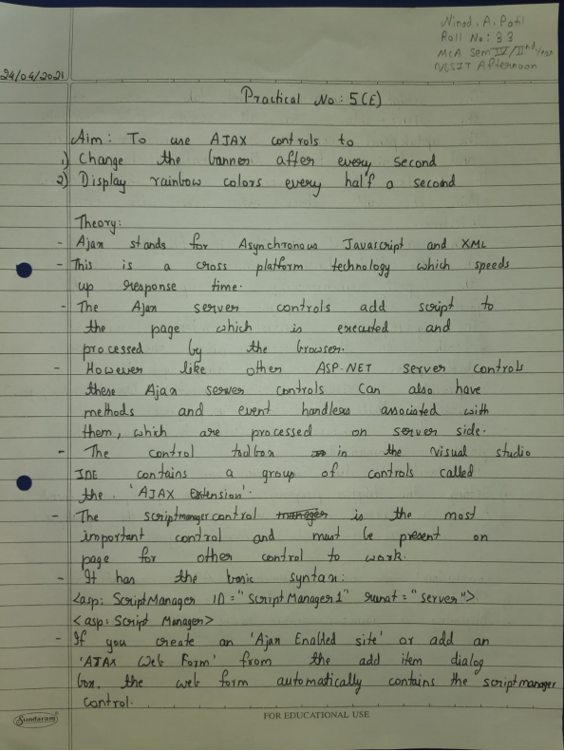

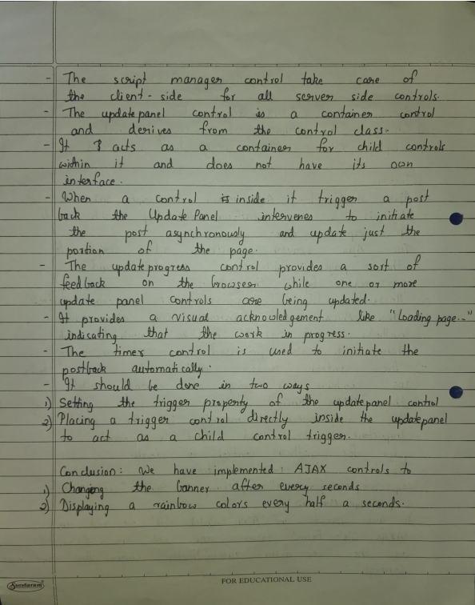

**Code:**

**WebForm1.aspx**

<%@ Page Language="C#" AutoEventWireup="true" CodeBehind="WebForm1.aspx.cs" Inherits="P5E.WebForm1" %>

<!DOCTYPE html PUBLIC "-//W3C//DTD XHTML 1.0 Transitional//EN" "http://www.w3.org/TR/xhtml1/DTD/xhtml1-transitional.dtd">

<html xmlns="http://www.w3.org/1999/xhtml">

<head runat="server">

</head> <body>

<h3>Changing the banner after every second</h3><br />

<form id="form1" runat="server"> <div>

<asp:ScriptManager ID="ScriptManager1" runat="server"/>

<asp:Timer ID="Timer1" Interval="1000" runat="server"/>

<asp:UpdatePanel ID="UpdatePanel1" runat="server">

<Triggers> <asp:AsyncPostBackTrigger ControlID="Timer1" EventName="Tick" /> </Triggers>

<ContentTemplate> <asp:AdRotator ID="AdRotator1" runat="server" AdvertisementFile="XMLFile1.xml" />

</ContentTemplate> </asp:UpdatePanel>

</div> </form>

</body> </html>

**XMLFile1.xml**

<?xml version="1.0" encoding="utf-8" ?>

<Advertisements> <Ad>

<ImageUrl>~/b1.png</ImageUrl>

<NavigationUrl>https://www.google.com/</NavigationUrl>

<AlternateText>pic1</AlternateText>

<Impressions>20</Impressions>

<keyword>small</keyword>

</Ad> <Ad>

<ImageUrl>~/b2.png</ImageUrl>

<NavigationUrl>https://www.google.com/</NavigationUrl>

<AlternateText>pic2</AlternateText>

<Impressions>20</Impressions>

<keyword>small</keyword>

</Ad> <Ad>

<ImageUrl>~/b3.png</ImageUrl>

<NavigationUrl>https://www.google.com/</NavigationUrl>

<AlternateText>pic3</AlternateText>

<Impressions>20</Impressions>

<keyword>small</keyword>

</Ad> <Ad>

<ImageUrl>~/b4.png</ImageUrl>

<NavigationUrl>https://www.google.com/</NavigationUrl>

<AlternateText>pic4</AlternateText>

<Impressions>20</Impressions>

<keyword>small</keyword>

</Ad> <Ad>

<ImageUrl>~/b5.png</ImageUrl>

<NavigationUrl>https://www.google.com/</NavigationUrl>

<AlternateText>pic5</AlternateText>

<Impressions>20</Impressions>

<keyword>small</keyword>

</Ad>

</Advertisements>

**WebForm2.aspx**

<%@ Page Language="C#" AutoEventWireup="true" CodeBehind="WebForm2.aspx.cs" Inherits="P5E.WebForm2" %>

<!DOCTYPE html PUBLIC "-//W3C//DTD XHTML 1.0 Transitional//EN" "http://www.w3.org/TR/xhtml1/DTD/xhtml1-transitional.dtd">

<html xmlns="http://www.w3.org/1999/xhtml">

<head runat="server">

</head> <body>

<h3>Displaying rainbow colors every half a second</h3>

<form id="form1" runat="server"> <div>

<asp:ScriptManager ID="ScriptManager1" runat="server"/>

<asp:Timer ID="Timer1" Interval="500" runat="server"/>

<asp:UpdatePanel ID="UpdatePanel1" runat="server">

<Triggers> <asp:AsyncPostBackTrigger ControlID="Timer1" EventName="Tick" /> </Triggers>

<ContentTemplate> <asp:AdRotator ID="AdRotator1" runat="server" AdvertisementFile="XMLFile2.xml" />

</ContentTemplate> </asp:UpdatePanel>

</div> </form>

</body>

</html>

**XMLFile2.xml**

<?xml version="1.0" encoding="utf-8" ?>

<Advertisements> <Ad>

<ImageUrl>~/violet.png</ImageUrl>

<NavigationUrl>https://www.openrainbow.com/en</NavigationUrl>

<AlternateText>violet</AlternateText>

<Impressions>20</Impressions>

<keyword>small</keyword>

</Ad> <Ad>

<ImageUrl>~/indigo.png</ImageUrl>

<NavigationUrl>https://www.openrainbow.com/en</NavigationUrl>

<AlternateText>indigo</AlternateText>

<Impressions>20</Impressions>

<keyword>small</keyword>

</Ad> <Ad>

<ImageUrl>~/blue.png</ImageUrl>

<NavigationUrl>https://www.openrainbow.com/en</NavigationUrl>

<AlternateText>blue</AlternateText>

<Impressions>20</Impressions>

<keyword>small</keyword>

</Ad> <Ad>

<ImageUrl>~/green.png</ImageUrl>

<NavigationUrl>https://www.openrainbow.com/en</NavigationUrl>

<AlternateText>green</AlternateText>

<Impressions>20</Impressions>

<keyword>small</keyword>

</Ad> <Ad>

<ImageUrl>~/yellow.png</ImageUrl>

<NavigationUrl>https://www.openrainbow.com/en</NavigationUrl>

<AlternateText>yellow</AlternateText>

<Impressions>20</Impressions>

<keyword>small</keyword>

</Ad> <Ad>

<ImageUrl>~/orange.png</ImageUrl>

<NavigationUrl>https://www.openrainbow.com/en</NavigationUrl>

<AlternateText>orange</AlternateText>

<Impressions>20</Impressions>

<keyword>small</keyword>

</Ad> <Ad>

<ImageUrl>~/red.png</ImageUrl>

<NavigationUrl>https://www.openrainbow.com/en</NavigationUrl>

<AlternateText>red</AlternateText>

<Impressions>20</Impressions>

<keyword>small</keyword>

</Ad>

</Advertisements>

**Output:**

**A. Change the banner after every second.**

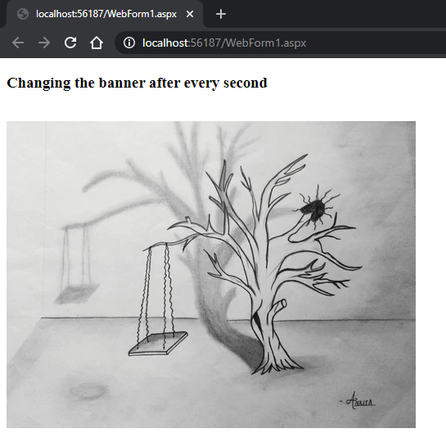 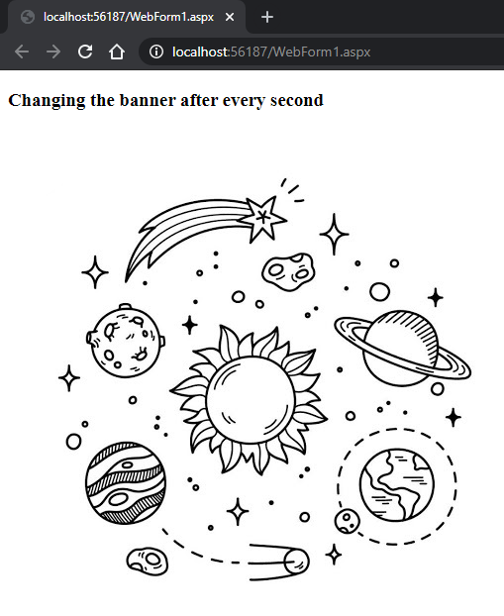

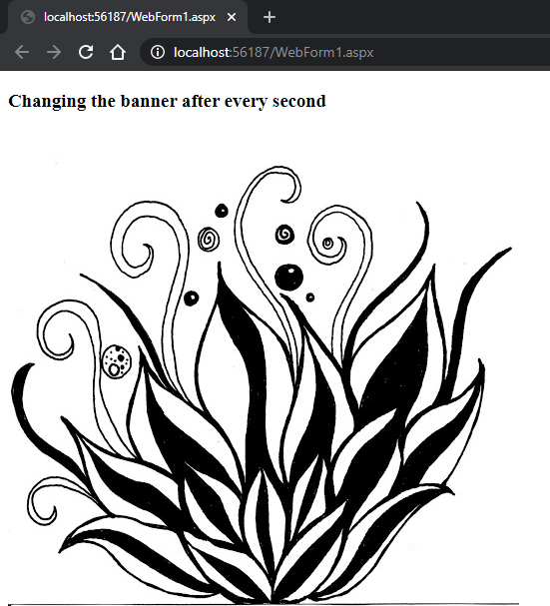 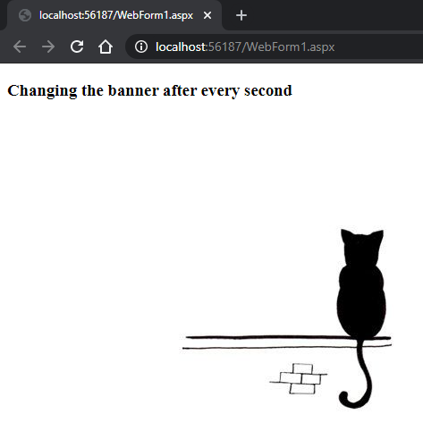

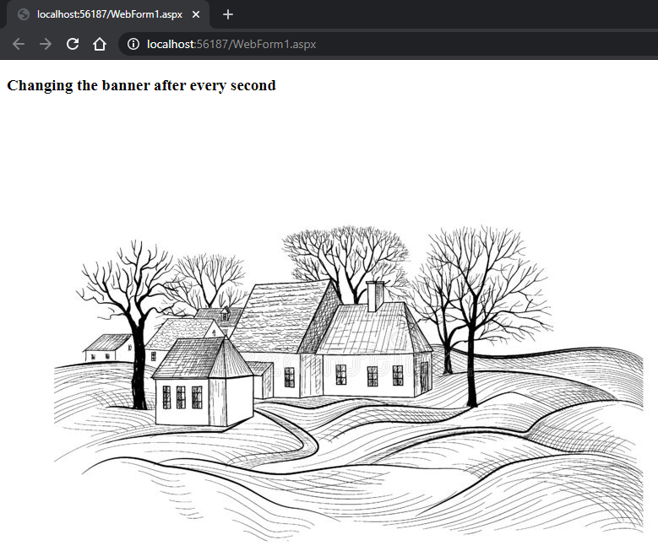

**B. Display rainbow colors every half a second.**

